Deliverable 4

We created a new repository named “FinalProjectRepo” on GitHub. Then I proceeded to upload the google collab project file and excel data sheet to the “FinalProjectRepo” repository on GitHub. I configured git with my git hub account using the commands :

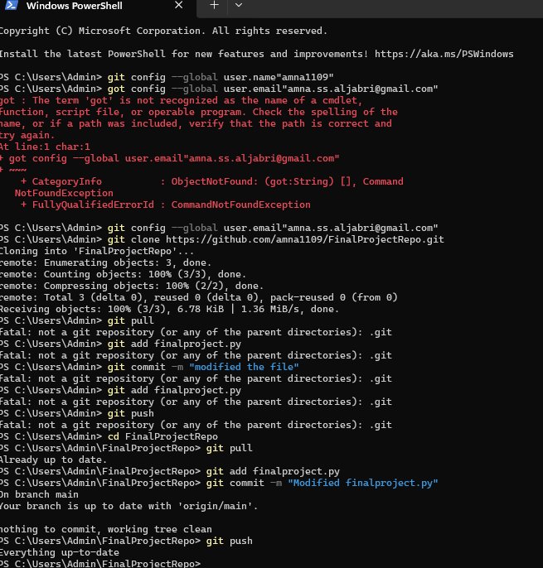

I cloned my GitHub repository to my local machine using the command:



I pulled the updated files from GitHub to my local repository, modified a pulled file, committed the changes locally, and pushed the modified file to GitHub using these commands:

